Ubiquity Camera System

# Table of Contents

Table of Contents 1

Overview 2

Setup Steps 2

Usage 2

# Overview

Security is a very important part of any school. One way to make a school more secure is to implement a functional and scalable security camera setup. It was decided that the best way to do this in the proposed school for Holmview is to use a ubiquiti unifi camera setup. This was chosen because it is scalable, easy to use and it is used in other schools around Queensland. The specific cameras that were chosen were the unifi g5 bullet cameras. This is because they can record in 1440p resolution for good picture clarity. They were also chosen because they are POE capable and waterproof.

# Setup Steps

1. Purchase UniFi cameras and network video recorder (NVR) (image below)

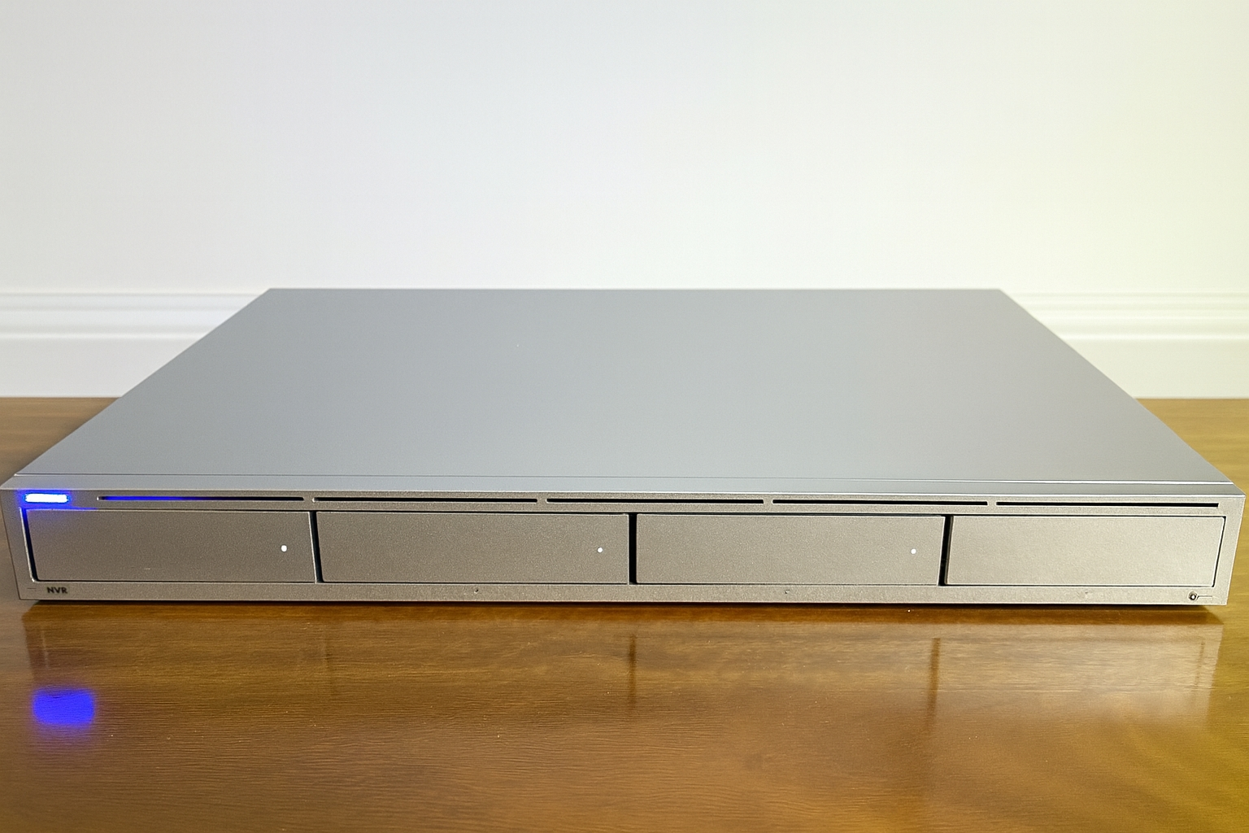

1. Run Ethernet cabling to each camera and back to a power over Ethernet (POE) switch
2. Load 3.5” or 2.5” drives into bays on the NVR
3. Cable the NVR to the switch
4. Cable the switch to the rest of the network
5. Power on the NVR
6. Create a Ubiquity account
7. Download the UniFi and Protect apps onto a mobile device or connect to the new NVR via IP
   1. Sign into the UniFi app and turn on Bluetooth
8. Connect the NVR to your account
   1. Go to the project app if using mobile
   2. Sign in and connect to the NVR
9. Accept terms and conditions
10. Run updates
11. When prompted, adopt cameras to the NVR
12. Configure camera recording settings to suit
13. Enable multi factor authentication

# Usage

This camera system has been very successful in prototyping so far. Cameras can be set to write to the hard drives all of the time or only when motion is detected. The below screenshot shows some of the motion events that the camera prototype has captured.

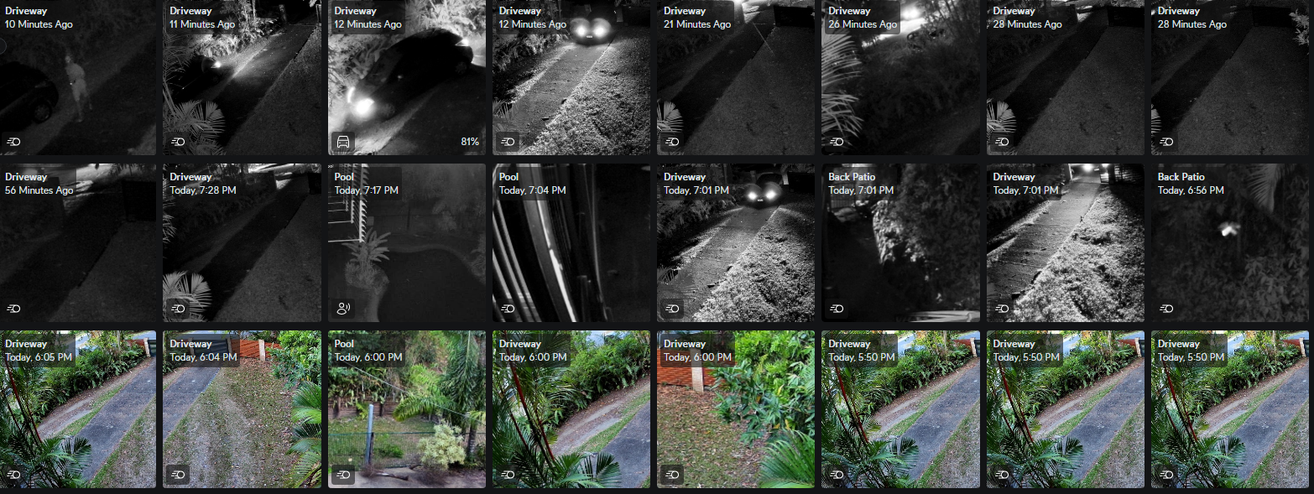Figure 1. Screenshot of Unifi Camera motion detection.

The network video recorder (NVR) has been setup with four 3TB hard drives providing 9 terabytes of usable storage space after utilising raid 5 for storage to provide redundancy of one hard drive allowing for higher availability. All of this is shown in the screenshot below.

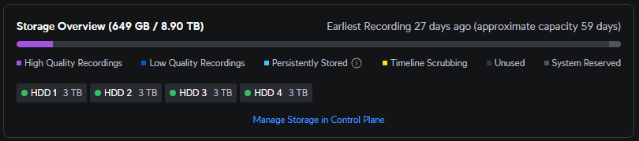Figure 2. Screenshot of storage information in Unifi Protect.

Each of the cameras can be controlled within Unifi Protect to have settings such as resolution, frame rate, IP address, device version, motion recording settings, facial recognition, motion zones and AI features adjusted. This allows for one central location for the adjustment of all of the cameras such that it is much easier for users to quickly make changes.

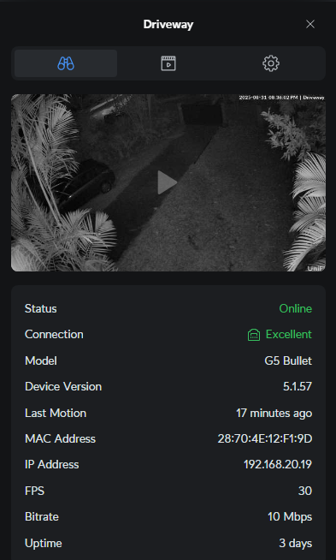

Figure 3. Camera settings page.

As mentioned above Unifi Protect is the central location where all of the cameras and recording can be managed. In order to access this software the user can log into the NVR directly via the console’s IP address and putting in a username and password then passing the multifactor authentication method that has been chosen. From there the user can change settings, review footage, save footage, manage software updates, notifications and backups. The console has it’s own backup system that is stored in the cloud for maximum security and stability. This backup schedule can be changed as per the users requirements. In order to restore a backup all the user needs to do is click restore and then click the backup they wish to restore.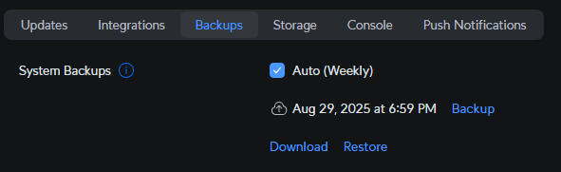Figure 4. Unifi Protect backup settings.